April 2024
Foreword from Eastleigh District Commander, Chief Inspector Matt Paling
Welcome to the April 2024 edition of the Policing the New Forest partnership newsletter.

Firstly, I hope you all had a wonderful Easter and were able to enjoy some time away from your offices and with your families.

This month, I want to bring you up to speed with the outcome of our recent County Lines Intensification Week, the latest in our bid to put a dent in the operation of drug dealing networks.

Last month, officers made arrests, seized drugs, gathered intelligence, disrupted offenders and safeguarded vulnerable people during a week of action against county lines drug dealing networks in Eastleigh. Here’s what took place…
Between Monday 4 March and Sunday 10 March, various drug-related operations and activities, were carried out across Hampshire, including the Eastleigh area.
The proactive work was undertaken by officers from a variety of teams, including Eastleigh Priority Crime Team, Eastleigh Neighbourhood Policing Team and Hedge End Neighbourhood Policing Team.
Officers also completed proactive foot, bicycle and vehicle patrols in identified hotspot areas across the district.
These patrols were both high-visibility and covert, with the aim being to disrupt any dealing activity, develop intelligence, safeguard vulnerable people, including juveniles and those being exploited by county lines networks.
Visits were also paid to known addresses for drug-related activity, where checks were completed on those residing at such properties, with the focus being on pursuing offenders, protecting those most at risk and preventing drug-related crime.
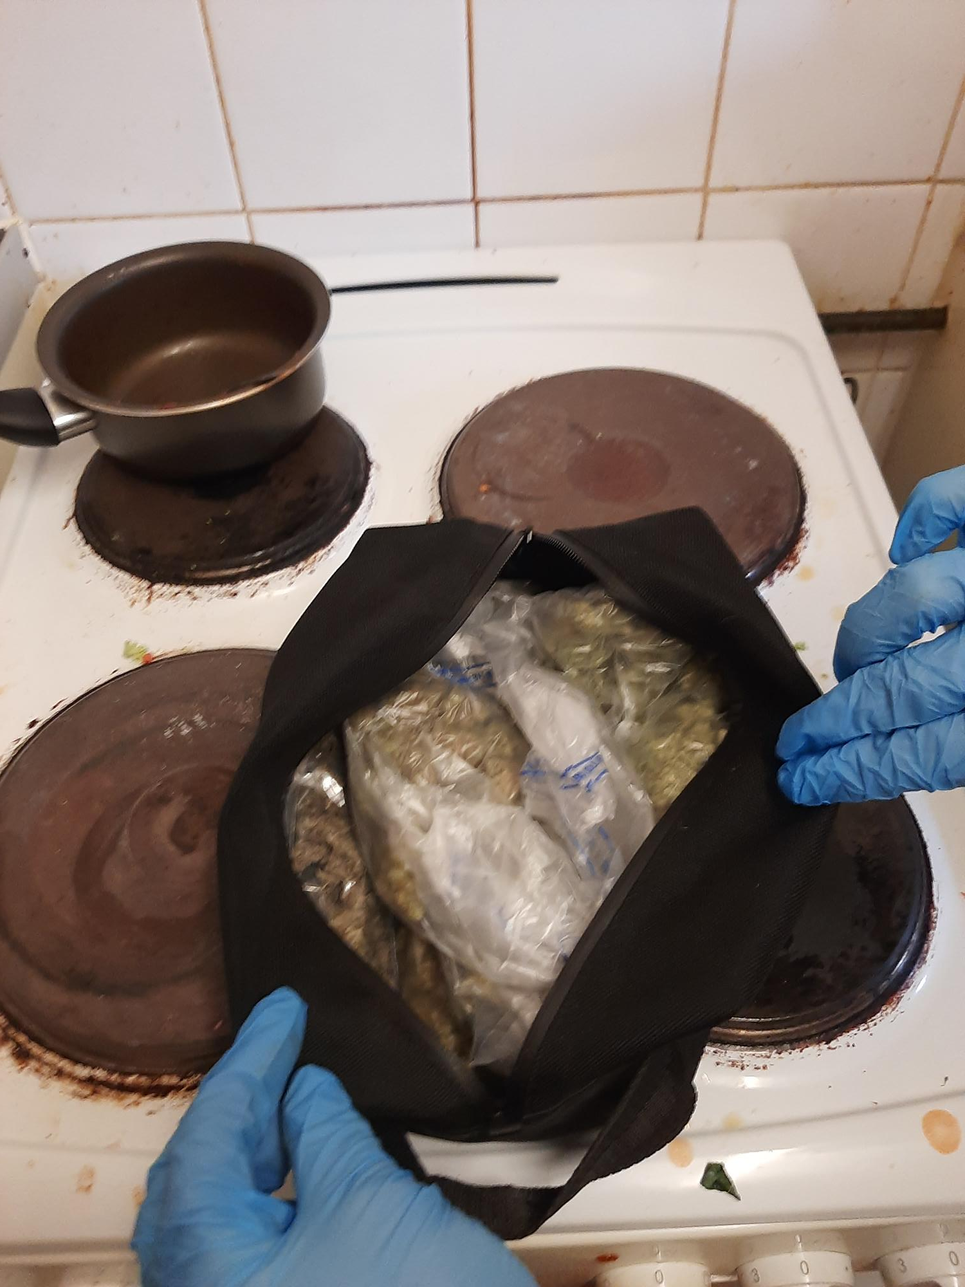
Additionally, safeguarding and educational visits were completed at local schools and colleges, with the intention being to deliver key messages, as well as target and engage with any young people in contact with drug lines, or involved in gang violence.
Drug users and drug support facilitators were also visited over the course of the week, with sign-posting and referrals made to local treatment centres for addiction where required or requested.
The continued effort is a clear message that drug-related activity will not be tolerated in our communities - this week of action is hopefully further evidence of that.
(Left, drugs seized from an address in Grantham Road, Eastleigh)
We will continue to relentlessly pursue and deal with those who are causing harm in our town, as well as offer support and safeguarding to those who are vulnerable to exploitation from county lines.
But of course, as we always say, we can only do what we do with the support and help of the community itself.
The information we receive from the public is vital to us being able to tackle illegal drug activity and support those who are vulnerable across our area.

Please continue to let us know of drug-related activity in the area in which you live, so we can allocate our resources to effectively and robustly deal with it.
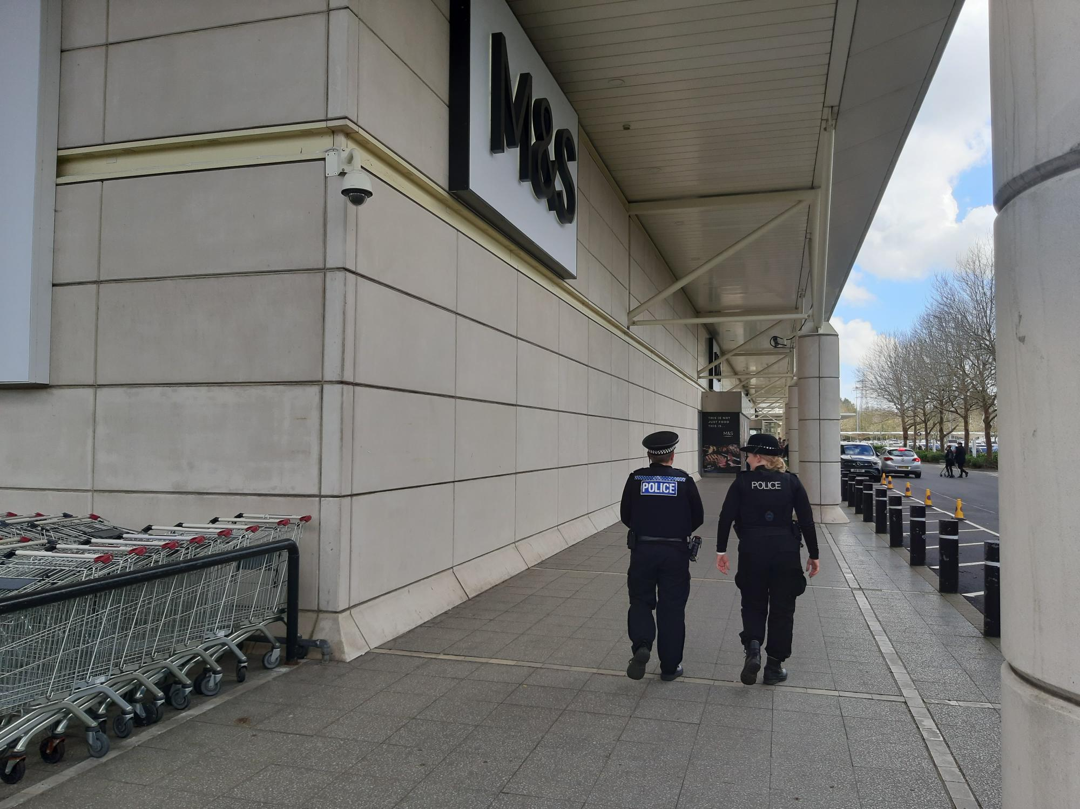
*County lines refer to when drug gangs from major cities set up networks in regional areas and use vulnerable people and children to carry, store and sell their drugs for them. The line refers to the phone line being used.
*Cuckooing is where criminal gangs use threats of violence or abuse in order to take over the homes of vulnerable people to deal drugs and commit other serious crimes.
(Right, PCs Peacock & Stoneley on patrol in Hedge End)

As always, we thank you for your cooperation and understanding as we deal with a wide variety of issues.

If you see anything suspicious or witness a crime, please report this to us by calling 101. If it is an emergency, dial 999 immediately.

A quick reminder that our Eastleigh Police and Hedge End Facebook pages are a great way to follow the team and the work they are doing to tackle crime in the local area in order to keep our communities safe.

You can also respond to our posts on our pages, ask questions and engage with teams. We will always do our best to reply to you on there, albeit this won’t always be instant.
Eastleigh District Commander
Chief Inspector Matt Paling

Investigation update…
Crime prevention advice issued following car key burglaries in Southampton, Eastleigh and Hedge End
Since the turn of the year, we have received eight reports of car key or ‘vamoose’ burglaries in the Southampton, Eastleigh and Hedge End areas.
These occurred between Saturday 13 January and Sunday 25 February and included the theft of a variety of makes and models.
In all eight cases, entry was gained to an address and keys subsequently stolen from within.
Offenders gained access to the addresses via insecure doors and windows, or by damaging key safes in order to reveal house keys.
More below…
Crime prevention advice issued following car key burglaries in Southampton, Eastleigh and Hedge End | Hampshire and Isle of Wight Constabulary

Two teenage boys arrested in connection with Eastleigh attempt robbery
Two teenage boys have been arrested in Chandler’s Ford on suspicion of attempt robbery.
A 16-year-old boy from Bursledon and 14-year-old boy from Chandler’s Ford were detained on the morning of Thursday 4 April.
It follows a report of an attempt robbery by a group of teenagers in the area of Romsey Road and Newtown Road shortly after 7pm on Sunday 31 March.
The 14-year-old boy was also arrested on suspicion of common assault of an emergency worker.
The two boys have since been released on conditional bail until Thursday 4 July, pending further enquiries.

Woman, 33, charged with shoplifting from Hedge End store

A 33-year-old woman from Totton has been charged with shoplifting from a Hedge End store.
Anna Marie Cooper, of Ashby Road, was arrested in Calmore Road shortly after 3pm on Wednesday 27 March.
It follows a report of a theft of clothing, including The North Face Diablo jackets, from Cotswold Outdoor, Lower Northam Road on Monday 12 February.
Cooper, who appeared at Southampton Magistrates’ Court on Thursday 29 March, has been remanded on conditional bail, to next appear at the same court on Monday 12 August.
Southampton woman sentenced for shoplifting from Hedge End store

A 29-year-old woman from Southampton has been sentenced for shoplifting from a Hedge End store.
Whitney Jay Hunt, of Winston Close, pleaded guilty to the theft of alcohol, which occurred at Sainsbury’s, Tollbar Way on Friday 24 November.
She was handed a three-month curfew order, with electronic monitoring, and was also ordered to pay £128 in compensation.
The sentencing took place at Southampton Magistrates’ Court on Tuesday 19 March.
Speaking following another recent sentencing for shoplifting, Dedicated Neighbourhood Officer and Local Bobby, PC Simon Peacock, made clear that shoplifting will not be tolerated from local shops and businesses.
More below…
Southampton woman sentenced for shoplifting from Hedge End store | Hampshire and Isle of Wight Constabulary

Man, 23, arrested on suspicion of vehicle theft in Hedge End

Officers have arrested a 23-year-old male from Swanmore on suspicion of possession of an offensive weapon in a public place and theft of motor vehicle.
The arrest took place in Kings Copse Avenue, Hedge End shortly after 1am on Thursday 14 March.
The man was also detained on suspicion of driving whilst disqualified and driving a motor vehicle otherwise than in accordance with a licence.

High value gold theft crime prevention Advice issued
The sharp rise in the price of gold means that jewellery is a serious target for burglars. Stolen items are often melted or sold on quickly.

Below is some very important advice, with some useful tips for keeping your gold yours. Please take a moment to read and share with family and friends.

Social Media update from our two Facebook accounts…

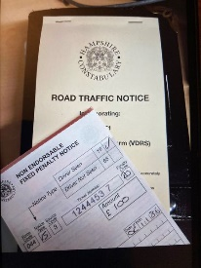
Following on from our post on Monday 11th March, regarding Anti-social Vehicle Nuisance and Unauthorised Car Meets in Hedge End, we would like to update on the following…

Read more here

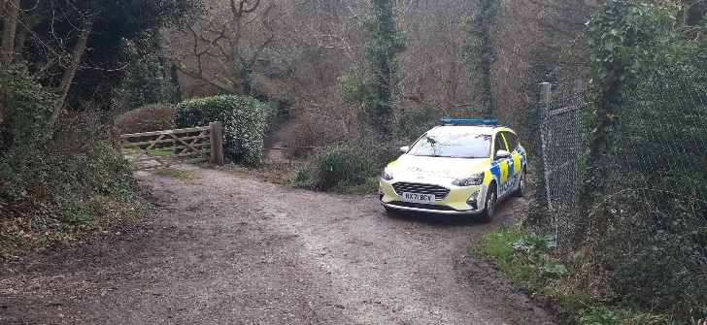
Bursledon and Hamble - Dangerous, Illegal and anti-social use of motorbikes. The Hedge End south team have undertaken an Operation in Hungerford, Bursledon this weekend following communication between the residents and visitors to the area about a group of motorbikes using the roads and footpaths in a dangerous and anti-social manner. Read more here

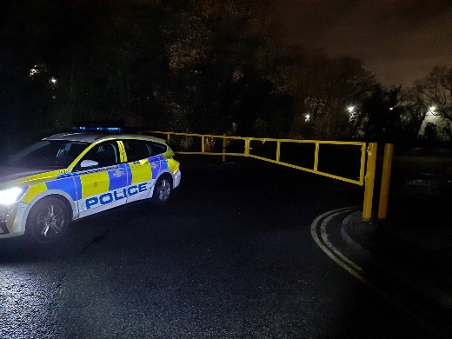
Good evening all, Just a very quick update regarding our local Road Policing Operations (in Hedge End North and Southern parishes),
Following our updates on the unauthorised Vehicle meets and events that have been happening in Hedge End business and retail car parks, we are pleased to inform the local community that our last Road Operation on Friday 15th March (from 9pm until the early hours), found the roads and hotspot car parks of Hedge End to be extremely quiet. Read more here
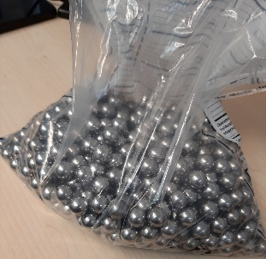
Officers from Hedge End North Neighbourhood Policing Team responded to reports of youths in possession of catapults, pointing these towards properties and animals.

Read more here

Our officers have been on patrol in Chandlers Ford specifically around North Millers Dale following a number of burglaries in the area. As such, we wanted to offer local residents some crime prevention advice.

Read more here

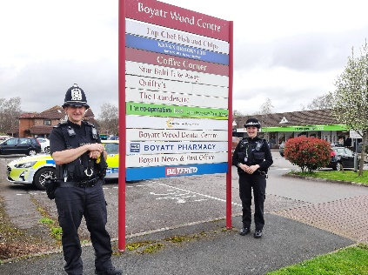
On Monday 18th March, Eastleigh Police including the Designated Neighbourhood Officers and Police Community Support Officers engaged with the Safer Business Action Week (SABA) by conducting reassurance patrols across Eastleigh Central, Bishopstoke, Fair Oak and Chandler’s Ford
Read more here

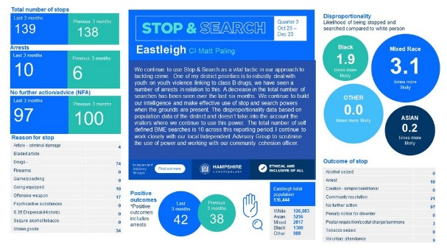
We have published our latest quarterly stop and search data for Eastleigh, covering the period from October 2023 to December 2023.

You can also find a text-only version of this graphic by going to our website: Stop and Search (Eastleigh) | Stop and Search | Hampshire and Isle of Wight Constabulary

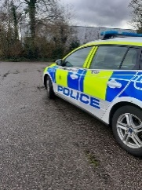
At approximately 20:15 this evening, Police received a report from Eastleigh CCTV Operators regarding a male that had been seen in the town centre, in possession of a knife.
Read more here

A 47-year-old man from Eastleigh has pleaded guilty to assault by beating of an emergency worker and common assault of an emergency worker.
Edward Darren Foote, of Southampton Road, appeared at Southampton Magistrates’ Court yesterday (Thursday 4 April).
Read more here

NO MORE: Since last Sunday (31 March), we have made arrests in connection with six assaults on our officers. Not only is that one a day, but it's also six too many. We will not tolerate violence towards our officers. Our PCs, PCSOs and Special Constables work tirelessly to protect the public, and we will always do likewise to make sure that they too are protected. Read more here

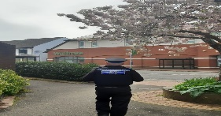
This morning we have been out patrolling around Fryern Arcade, Chandlers Ford and the surrounding area with our aim being to identify and target any anti-social behaviour as well as to engage with our local shops and community. Read more here

Our Priorities
- Tackling youth-on-youth violence across the district

- Targeting those who are committing burglaries and theft from motor vehicles

- Dealing with those causing anti-social behaviour and preventing further incidents of ASB

Please feel free to contact your local inspector with any query you may have, or go direct to District
Commander, Chief Inspector Matt Paling via matt.paling@hampshire.pnn.police.uk

Inspector Steven Goodall
Inspector for Hedge End Neighbourhood Policing Team
Inspector Andrew Mooge
Inspector for Eastleigh Neighbourhood Policing Team
Police Sergeant Thomas Hannam
Hedge End North
Police Sergeant Suzanne Badham
Hedge End South
Police Sergeant Thomas Cottrell
Eastleigh Central

Police Sergeant Shane Hebburn
Eastleigh East & West

Want to stay informed? Register for Hampshire Alerts

As a local resident, you can play a key role in helping us to prevent and detect crime and anti-social behaviour.

Improving the flow of information between the local community and the police is vital to achieving our aim to work together to deter criminals.

By signing up to Hampshire Alerts, you will receive timely updates covering crime prevention advice, crime alerts and witness appeals for incidents in the local community. It is your way of being kept informed of what we’re doing in the community, allowing us to keep the communities of Eastleigh and Hedge End safe.

Click here to sign-up to receive regular Hampshire Alerts

Neighbourhood Policing Team - Hampshire Alert

Keep in touch with us on social media
If you want to know what our officers are doing in the district to reduce criminal activity in our local community, why not follow us on social media?

Join us on Facebook @EastleighPolice / @HedgeEndPolice

